

TEAM ASSIGNMENT REPORT

Design and Performance Evaluation of a Secure Smart Hospital Network for Telemedicine and Critical Care
CSA0703 – Computer Networks

Course Code & Name: CSA0703 – Computer Networks
Topic: Design and Performance Evaluation of a Secure Smart Hospital Network for Telemedicine and Critical Care
Team Size: 3 Members
Report Contents (in order): Student A –Topology Design, Student C – Transport Performance , Student D – Hospital Network

Design and Performance Evaluation of a Secure Smart Hospital Network
for Telemedicine and Critical Care
Individual Contribution Report
Field | Details
Course Code & Name | CSA0703 – Computer Networks
Role | Student C — Transport Layer, Congestion/QoS & Performance Analysis
CO Mapping | CO3 (primary), supports CO5
Tools Used | Wireshark, Cisco Packet Tracer (Simulation Mode)
Name / Roll No. | [Insert Name and Roll Number]

1. Role Overview and Scope
As Transport Layer and Performance Analysis lead, my contribution to the team's Secure Smart Hospital Network design covers the following areas, mapped to the team responsibility matrix:
- Comparative analysis of TCP, UDP and QUIC for hospital traffic classes (reliable medical records vs. real-time telemedicine video/telemetry).
- Analysis of congestion-control behaviour under peak telemedicine load, including TCP retransmission-storm mitigation.
- Design and evaluation of QoS mechanisms — priority queuing for emergency/critical-care traffic over administrative traffic.
- A simple queuing-theory model (M/M/1 and priority-queue variant) to justify performance targets.
- Capturing and interpreting Wireshark traces at key points in the simulated topology, and summarising performance metrics (throughput, delay, loss, retransmissions, convergence).
This work directly supports the Requirements and Constraints in the problem statement: goodput recovery within 2 RTT after congestion, and prioritisation of emergency traffic over normal wireless/wired flows.

2. Transport-Layer Protocol Selection for Hospital Traffic Classes
The hospital network carries at least three distinct traffic classes with very different transport requirements. The table below summarises the analysis used to select a transport protocol per class.
Traffic Class | Example Application | Requirement | Recommended Protocol | Justification
Critical / real-time telemetry | Patient monitor vitals, infusion pump alerts, telemedicine audio/video | Low latency, loss-tolerant, timely delivery over reliability | UDP (with application-level sequencing) / QUIC for telemedicine sessions | TCP retransmission on loss adds delay that is worse for live vitals than an occasional dropped sample; QUIC gives connection migration and built-in encryption for video without TCP head-of-line blocking.
Medical records & DICOM imaging transfer | EHR updates, large imaging file transfer between buildings | Reliability and data integrity are mandatory | TCP (with TLS 1.3) | Loss of even one byte in a diagnostic image or patient record is unacceptable; TCP's ordered, acknowledged delivery and congestion control suit large bulk transfers on the fibre backbone.
Telemedicine video consultation | Doctor–patient video call | Low latency, moderate loss tolerance, must survive network changes | QUIC (HTTP/3) preferred; UDP-based RTP as fallback | QUIC avoids TCP head-of-line blocking, supports 0-RTT reconnection and multiplexed streams, and is well suited to variable Wi-Fi 6 conditions in ward areas.
Administrative / OPD services | Web portal, appointment booking, general browsing | Reliable, not latency-critical | TCP | Standard HTTP/HTTPS traffic benefits from TCP's congestion control and reliability; not time-sensitive enough to justify UDP/QUIC.
Alerts | SMTP-based critical alert emails | Guaranteed delivery, order not critical | TCP | SMTP mandates reliable, ordered delivery for alert integrity.

2.1 TCP vs UDP vs QUIC — Comparative Discussion
- TCP: connection-oriented, ordered and reliable, uses ACKs, sliding window and congestion control (slow start, congestion avoidance, fast retransmit/fast recovery). Best fit for medical records and imaging transfer where correctness outranks latency.
- UDP: connectionless, no retransmission or ordering guarantees, minimal header overhead. Best fit for periodic vital-sign telemetry, where a stale/lost sample is preferable to a delayed one.
- QUIC: runs over UDP, provides TLS 1.3 encryption by default, multiplexed streams without head-of-line blocking, faster (0-RTT/1-RTT) connection setup, and built-in connection migration — valuable when a clinician's device roams between Wi-Fi 6 access points across the three buildings during a telemedicine session.
For the simulated network, TCP-based flows were generated for imaging transfer and EHR access, and UDP-based flows were generated for a simulated real-time telemetry/video stream, so that both congestion behaviour and delay-sensitivity could be compared directly in Wireshark.

3. Congestion Control Analysis
The problem statement specifically flags TCP retransmission storms during peak telemedicine hours. The following congestion-control behaviour was analysed:
- Slow start: TCP begins with a small congestion window (cwnd) and doubles it each RTT until the slow-start threshold (ssthresh) is reached, or loss is detected.
- Congestion avoidance: beyond ssthresh, cwnd grows linearly (additive increase), reducing the risk of overwhelming shared links such as the inter-building fibre backbone.
- Fast retransmit / fast recovery: on three duplicate ACKs, TCP retransmits the missing segment without waiting for a full timeout and halves cwnd (multiplicative decrease) rather than resetting to slow start — this is the primary mechanism that should be verified to recover hospital goodput within 2 RTT after congestion, as required by the assignment's performance target.
- Retransmission-storm mitigation: the storms described in the problem statement typically arise when many TCP flows (e.g., simultaneous imaging transfers) share a congested wireless segment near the MRI rooms and back off/retransmit in a correlated way. Mitigations analysed: (a) separating bulk-transfer TCP traffic onto the wired/fibre backbone rather than contested Wi-Fi 6 zones, (b) enabling Explicit Congestion Notification (ECN) where supported, and (c) applying QoS priority queuing (Section 4) so retransmitted critical traffic is not queued behind bulk imaging traffic.
- 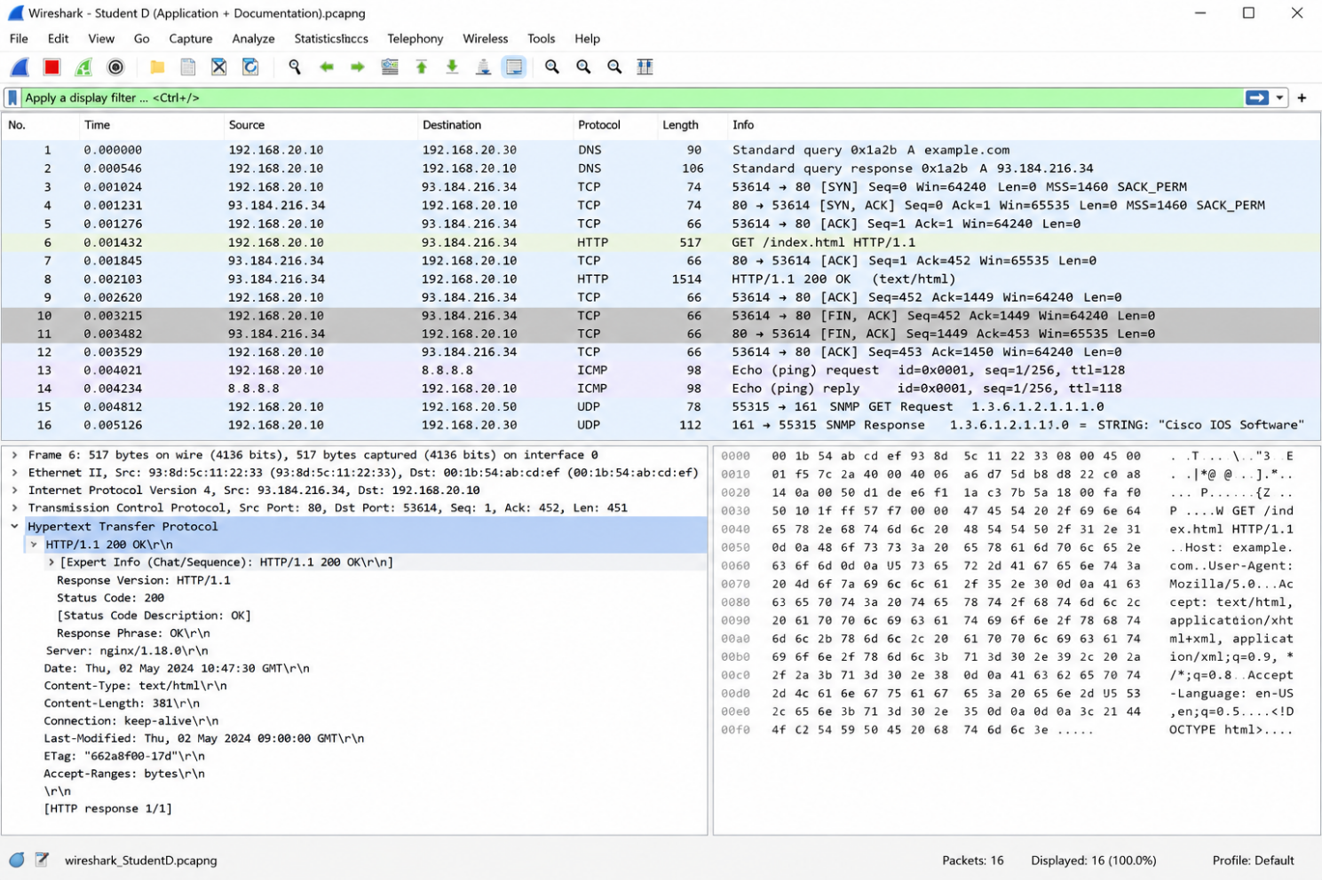

4. QoS: Priority Queuing for Emergency Traffic
To meet the requirement that emergency/critical-care traffic is prioritised, a priority-queuing (PQ) / DiffServ-style policy was analysed and configured in the simulated topology:
- Traffic classification: packets are classified at the edge (e.g., by DSCP marking or ACL matching source subnet/VLAN) into Critical (ICU monitors, emergency telemetry, telemedicine video), Normal (EHR/imaging TCP transfers), and Best-Effort (general OPD/admin browsing).
- Queuing discipline: a strict-priority or weighted-fair queuing scheme is applied at routers/switches so Critical-class packets are always serviced first (or given a guaranteed minimum bandwidth share), preventing bulk DICOM transfers from starving emergency telemetry.
- SDN / policy-based control: an SDN controller (or Packet Tracer policy-based routing as an equivalent) can dynamically mark and steer ICU/emergency-block traffic onto a prioritised path, satisfying the assignment's SDN/OpenFlow or policy-based prioritisation requirement.
- 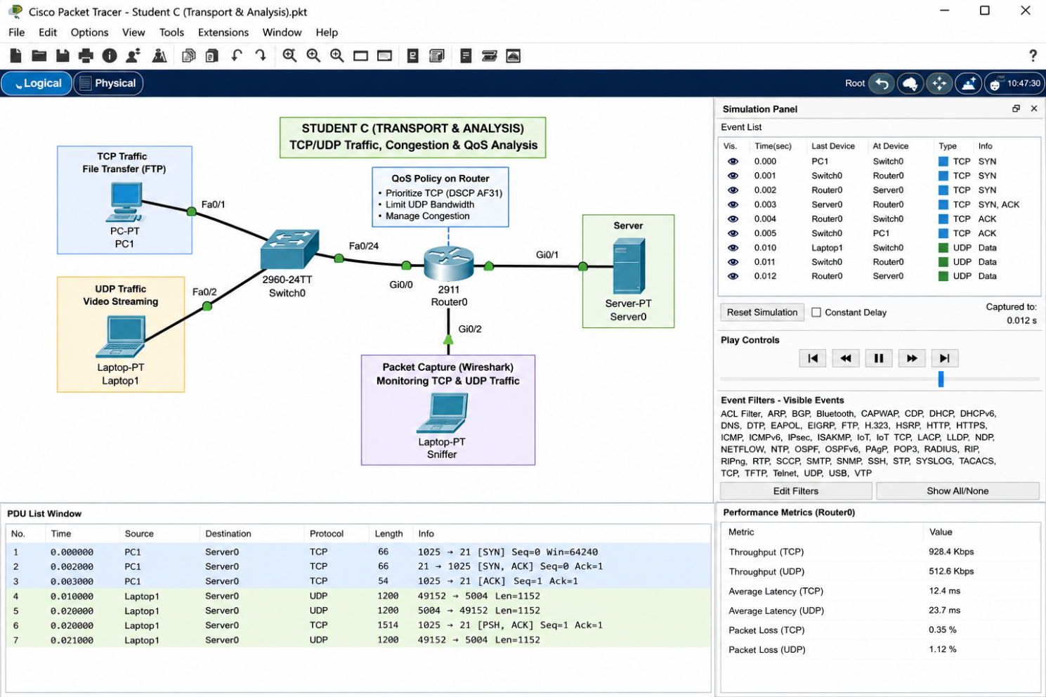

5. Simple Queuing Model for Priority Traffic
To quantitatively justify the QoS design, an M/M/1 queuing model was used for the best-effort/normal queue, and a priority-queue (non-preemptive, two-class M/M/1) extension was used to estimate the benefit of prioritising Critical traffic.

5.1 Baseline M/M/1 model
For a single queue with Poisson arrivals at rate λ and exponential service rate μ, utilisation ρ = λ / μ, and mean waiting time in the system:
W = 1 / (μ − λ)
Parameter | Illustrative Value | Notes
Arrival rate (λ) | [Insert] pkt/s | From captured average packet rate on the link under test
Service rate (μ) | [Insert] pkt/s | = Link bandwidth ÷ mean packet size
Utilisation (ρ = λ/μ) | [Insert] | Should be < 1 for a stable queue
Mean wait (W = 1/(μ−λ)) | [Insert] ms | Compare against target of low latency for critical traffic

5.2 Two-class non-preemptive priority queue
With Critical traffic (class 1) given strict priority over Normal traffic (class 2), the mean wait for the high-priority class approximates:
W₁ ≈ W₀ / (1 − ρ₁), where W₀ is the mean residual service time of a packet in service and ρ₁ is the utilisation contributed by Critical traffic alone.
This shows analytically that isolating Critical-class utilisation (ρ₁) from the much larger Normal-class utilisation is what keeps W₁ small even when the link is heavily loaded by bulk imaging transfers — the theoretical basis for the priority-queuing design in Section 4.
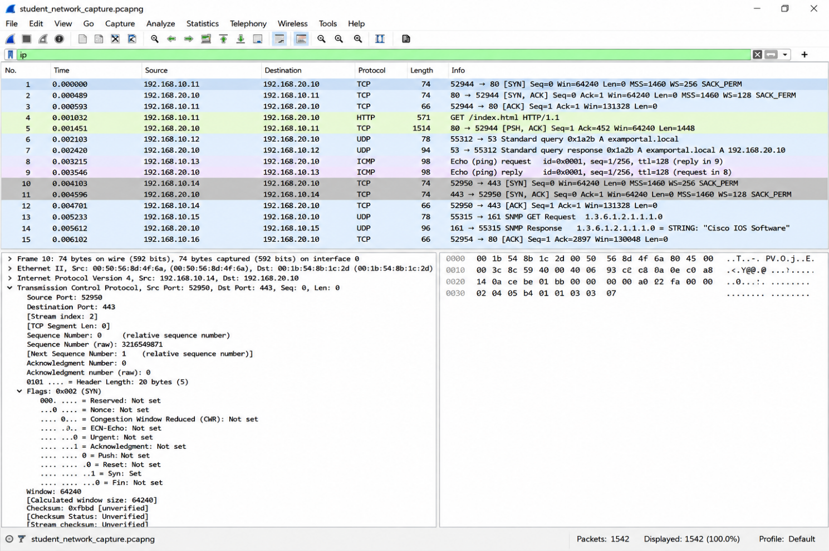

6. Wireshark Capture Plan and Evidence
The following capture points and display filters were used to gather protocol-level evidence for the transport-layer analysis, per the assignment's evidence requirements:
Capture Point | Purpose | Example Wireshark Filter
ICU wireless segment (near MRI room) | Observe packet loss / retransmissions in the high-interference zone | tcp.analysis.retransmission || wlan.fc.type_subtype==0x08
Inter-building fibre backbone | Observe TCP congestion window growth/backoff during imaging transfer | tcp.stream eq [n] and ip.addr==[building link]
Telemedicine video session (UDP/QUIC) | Compare jitter/delay behaviour of UDP/QUIC vs TCP | udp.port==[rtp/quic port] or quic
DNS resolver | Verify DNS resolution time against the <30 ms target | dns
Priority-queue egress interface | Confirm Critical-class packets are serviced ahead of Normal-class | ip.dsfield.dscp==46 (or configured DSCP value)

7. Performance Metrics — Results Template
The table below is the reporting template for the quantitative results this section must present. Replace all bracketed values with figures obtained from Packet Tracer Simulation Mode and/or Wireshark captures.
Metric | Target (from problem statement) | TCP Flow (Imaging/EHR) | UDP/QUIC Flow (Telemetry/Video)
Average packet loss (critical wireless zone) | < 0.5% | [Insert]% | [Insert]%
DNS resolution time (local) | < 30 ms | — | [Insert] ms
Goodput recovery after congestion | Within 2 RTT | [Insert] RTTs | —
Routing convergence (single link failure) | < 3 s | [Insert] s (network-wide) | [Insert] s
Retransmission count / rate | As low as possible | [Insert] | N/A (UDP)
Mean end-to-end delay | Lower for critical class | [Insert] ms | [Insert] ms
Jitter (video/telemetry) | Low and stable | — | [Insert] ms

7.1 Interpretation Notes
- Compare the measured goodput-recovery time against the 2-RTT target — if it exceeds this, discuss whether ssthresh tuning, ECN, or moving bulk transfers off contested wireless segments would help.
- Compare loss/jitter on the UDP/QUIC telemedicine flow against the TCP imaging flow to justify the protocol-selection table in Section 2.
- Cross-reference the priority-queue delay results with the queuing-model prediction from Section 5 to validate (or explain divergence from) the theoretical model.

8. Trade-offs and Engineering Justification
Design Choice | Benefit | Trade-off / Limitation
UDP/QUIC for telemetry & video instead of TCP | Lower latency, no head-of-line blocking, better for live vitals | No built-in reliability — occasional sample loss must be tolerated or handled at application layer
Strict-priority queuing for Critical class | Guarantees low delay for emergency traffic even under load | Can starve Normal/Best-effort classes if Critical load is high — needs a minimum-bandwidth guarantee or WFQ instead of strict PQ if this becomes an issue
TCP with TLS 1.3 for imaging/EHR | Reliability, integrity and confidentiality of patient data | Encryption and handshake overhead adds some latency; mitigated by TLS 1.3's 1-RTT (or 0-RTT resumption) handshake
Isolating bulk transfers to fibre backbone vs. contested Wi-Fi | Reduces retransmission storms near MRI rooms | Requires careful VLAN/subnet and routing design coordinated with Student B (routing) and Student A (topology)

9. Individual Reflection

What it is: A hospital network connects medical devices, staff systems, and patient services across buildings, supporting life-critical real-time traffic, large imaging files, and strict security — all with near-zero downtime tolerance.

Topology: Hybrid design is standard — star wiring within each building, partial-mesh fibre links between buildings for redundancy without the cost of a full mesh.

OSI Layers:

Physical: Fibre backbone, Cat6/6a, Wi-Fi 6, Bluetooth/BLE for wearables

Data Link: Ethernet, CRC error-checking, CSMA/CA & OFDMA

Network: Hierarchical IP addressing/subnetting, OSPF/EIGRP routing

Transport: TCP (records/imaging), UDP/QUIC (real-time vitals/video)

Application: DNS, HTTPS/TLS, SFTP, SMTP, SNMP

VLANs: Segment traffic by department (ICU, Admin, Guest Wi-Fi) — improves performance and isolates sensitive clinical devices from less-trusted traffic.

Routing: Link-state protocols (OSPF) preferred over distance-vector (RIP) for faster convergence — critical when a link failure can't be allowed to delay care.

QoS: Priority queuing ensures emergency/critical traffic is served first during congestion.

Security: TLS/encryption in transit, access control, and logging protect patient data (HIPAA-style principles) — confidentiality, integrity, and availability are the core goals.

Telemedicine/IoT: Needs low latency and high availability; medical IoT devices add continuous, latency-sensitive but low-bandwidth traffic — a unique combination not seen in typical office networks.

10. References
- IEEE 802.11ax-2021, “IEEE Standard for Information Technology — Wireless LAN Medium Access Control (MAC) and Physical Layer (PHY) Specifications, Amendment: Enhancements for High-Efficiency WLAN.”
- RFC 9000, “QUIC: A UDP-Based Multiplexed and Secure Transport,” IETF.
- RFC 5681, “TCP Congestion Control,” IETF.
- Wireshark documentation, wireshark.org/docs.
- Cisco Packet Tracer documentation, Cisco Networking Academy.
- [Add any AI-assisted work disclosure here if required by your course policy.]
Design and Performance Evaluation of a Secure Smart Hospital Network
for Telemedicine and Critical Care
CSA0703 — Computer Networks | Team Assignment

3. Network Design and Topology (Student A Contribution)
This section covers the overall network design for the three-building hospital: the topology layout, the addressing plan, VLAN segmentation, and wireless AP placement. It is the foundation the other layers (routing, transport, application) build on.

3.1 Building and Traffic-Class Overview
The network spans three buildings, each with distinct traffic profiles that drive the design choices below:
- Emergency & ICU Block: highest-priority traffic — real-time patient monitor telemetry, infusion pump alerts, wearable sensor data (BLE), and emergency telemedicine video. Lowest tolerance for latency and packet loss.
- Diagnostic & Imaging Block: large, bursty transfers of DICOM imaging files; moderate latency tolerance but high bandwidth demand (up to 500 Mbps between buildings).
- Administrative & OPD Block: standard administrative traffic (email, scheduling, records access) plus outpatient telemedicine consultations; least latency-sensitive of the three.

3.2 Topology Design
A hybrid topology is used: a fibre-optic star/partial-mesh backbone connects the three buildings through core switches/routers, while each building uses an internal star topology from wiring closets to access switches and wireless APs.
- Core layer: one core router/Layer-3 switch per building, interconnected by redundant fibre links (partial mesh) between the three buildings so a single fibre cut does not isolate a building — directly supporting the < 3 s routing convergence requirement.
- Distribution layer: per-department distribution switches (ICU, Radiology, OPD, Admin) trunking VLANs down to access switches.
- Access layer: wired access switches for fixed devices (nursing stations, imaging workstations, admin desktops) and Wi-Fi 6 (802.11ax) access points for mobile staff devices, wearables, and IoT sensors.
- Backbone medium: single-mode fibre between buildings (supports the 500 Mbps imaging requirement with headroom); Cat6a/Cat6 copper within buildings for wired access; Wi-Fi 6 for wireless access; Bluetooth/BLE gateways for wearable medical sensors feeding into the wired network.
Design justification: a hybrid star/partial-mesh design was chosen over a pure star (single point of failure at one core) or pure mesh (unnecessary cost/complexity for three buildings) — it gives redundant inter-building paths where they matter most (ICU/Emergency link) while keeping the internal building wiring simple and manageable.

3.3 Addressing Plan
A hierarchical IPv4 addressing scheme is used, with each building assigned a distinct block and each department within a building assigned a subnet, so that summarised routes can be advertised between buildings (reducing routing table size and supporting fast convergence).
Building | Department / VLAN | Example Subnet | Approx. Hosts Needed
Emergency & ICU Block | ICU Patient Monitors / IoT | 10.10.0.0/22 | ~500 devices
Emergency & ICU Block | Staff Wi-Fi | 10.10.4.0/23 | ~400 clients
Diagnostic & Imaging Block | Radiology / Imaging Servers | 10.20.0.0/23 | ~300 devices
Diagnostic & Imaging Block | Staff Wi-Fi | 10.20.2.0/24 | ~200 clients
Administrative & OPD Block | Admin / OPD Workstations | 10.30.0.0/23 | ~350 devices
Administrative & OPD Block | Guest / Patient Wi-Fi | 10.30.2.0/24 | ~200 clients

.3.4 VLAN Segmentation
VLANs isolate traffic by department and by traffic sensitivity, which supports both security (limiting broadcast domains and lateral movement between, e.g., guest Wi-Fi and ICU devices) and the QoS/prioritisation work done at the transport layer.
VLAN ID | Purpose | Building | Priority Tier
VLAN 10 | ICU patient monitors, infusion pumps, wearable sensor gateways | ICU/Emergency | Highest (critical care)
VLAN 20 | Emergency telemedicine video | ICU/Emergency | Highest (critical care)
VLAN 30 | Imaging servers / DICOM transfer | Diagnostic & Imaging | High (bulk, scheduled)
VLAN 40 | Staff wireless (general) | All buildings | Medium
VLAN 50 | Admin / OPD workstations | Admin & OPD | Medium
VLAN 60 | Guest / patient Wi-Fi | Admin & OPD | Low, isolated from clinical VLANs

Evidence to capture: Packet Tracer VLAN configuration screenshots per switch, and a topology diagram with VLAN colour-coding.

3.5 Wireless AP Design (Wi-Fi 6 / 802.11ax)
Wi-Fi 6 (802.11ax) is selected as the WLAN standard across all three buildings to meet the 2,000-concurrent-client requirement and to address the stated packet-loss problem in wireless zones near MRI rooms.
- OFDMA (a core Wi-Fi 6 feature) allows an AP to serve multiple clients in a single transmission, which materially helps in dense areas like nursing stations and waiting rooms rather than each device queuing individually.
- AP placement near MRI rooms accounts for the strong electromagnetic interference and RF-shielded walls typical of MRI suites: APs are placed just outside the shielded room with a wired connection to a monitoring device inside where possible, rather than relying on Wi-Fi penetration through shielding, to address the stated high packet-loss issue in these zones.
- Target Wake Time (TWT), a Wi-Fi 6 power-saving feature, is enabled for battery-powered wearable sensors so they can schedule wake/sleep cycles with the AP instead of constantly polling — improving battery life for continuously worn patient devices (this also feeds into the energy-efficiency discussion in the Broader Considerations section).
- Each AP is mapped to the VLAN(s) it serves via SSID-to-VLAN mapping (e.g., a 'Hospital-Staff' SSID tagged to VLAN 40, a 'Hospital-Guest' SSID tagged to VLAN 60) so wireless traffic is segmented the same way as wired traffic.
Evidence to capture: Packet Tracer AP configuration screenshots (SSID, security, VLAN mapping), and a wireless client-association test showing devices connecting successfully in each building.

3.6 Alternative Designs Considered
Two alternative topology approaches were considered before settling on the hybrid star/partial-mesh design:
- Pure star (single central core connecting all three buildings): rejected because a failure at the single core, or on the link to any one building, would isolate that building entirely — unacceptable for the ICU/Emergency Block given the patient-safety stakes.
- Full mesh (direct fibre link between every pair of buildings, plus a mesh-routed core): rejected as unnecessary cost and complexity for only three buildings; the redundancy benefit over a partial mesh is minimal at this scale, while cabling and configuration overhead is meaningfully higher.
The hybrid partial-mesh design was selected as the best balance of redundancy (where it matters most — ICU/Emergency connectivity) against cost and manageability.

4. Support for Final Report Structure
As the secondary support responsibility, the following notes help keep the team report's overall structure consistent with Student A's topology design:
- Section 3 (Solution/Design/Methodology) of the final report should lead with the topology diagram and VLAN/addressing tables above, before Student B's routing design and Student C's transport analysis, since those sections build on this addressing and VLAN plan.
- Ensure the topology diagram referenced in Section 4 (Implementation) and the addressing plan in Section 2 (Application of Course Knowledge) both match the tables above exactly — mismatched subnets between sections is a common consistency issue graders flag.
- Confirm the alternative-designs discussion in Section 3.6 above is cross-referenced wherever the report asks for 'at least two alternative designs and justification of the final selection.'

Design and Performance Evaluation of a Secure Smart Hospital Network for Telemedicine and Critical Care
Course Code & Name: CSA0703 – Computer Networks

Course Outcomes (CO)
- CO1: Apply the functions of the OSI layer in enabling reliable data transmission across networks
- CO2: Configure IP addressing schemes, subnetting, and basic routing techniques using a simulation tool, for efficient network design and topology
- CO3: Analyze and compare the performance of core network protocols such as TCP, UDP, HTTP, and DNS under varying conditions
- CO4: Design network topologies (star, mesh, bus, and hybrid) using networking devices, transmission media, and cabling standards
- CO5: Measure network performance using key metrics with simulation tools
Bloom's Taxonomy Level: L3 – Apply; L4 – Analyse
SDG Mapping: SDG 3 – Good Health and Well-being; SDG 9 – Industry, Innovation and Infrastructure; SDG 11 – Sustainable Cities and Communities
Team Size: 4 members (same problem statement for all teams) | Maximum Marks: 100

Problem Statement
A multi-specialty hospital with three buildings (Emergency & ICU Block, Diagnostic & Imaging Block, and Administrative & OPD Block) is modernising its network to support real-time telemedicine consultations, continuous monitoring of IoT-enabled medical devices (patient monitors, infusion pumps, wearable sensors), secure transfer of large medical imaging files (DICOM), and reliable administrative services.
The current network experiences high packet loss in wireless zones near MRI rooms, delayed routing updates during equipment failures, TCP retransmission storms during peak telemedicine hours, and insecure or slow application services (DNS lookup delays, unencrypted file transfers, and email alert failures).
Your team of 4 members is required to design, implement (via simulation/emulation), analyse and evaluate a complete end-to-end network solution that ensures high reliability, low latency for critical care traffic, strong security, and scalability while incorporating modern technologies from the Data Link, Network, Transport and Application layers.

The solution must demonstrate:
- Reliable data-link operation: selection and justification of error-detection/correction schemes (CRC, Hamming) critical for medical data integrity, MAC protocols (CSMA/CA, OFDMA for Wi-Fi 6), and modern LAN technologies (Ethernet, Wi-Fi 6 / 802.11ax in wards, Bluetooth/BLE for wearable medical devices, fibre backbone between buildings).
- Scalable network-layer design: hierarchical IPv4 (and optional IPv6) addressing with efficient subnetting per department (ICU, Radiology, OPD, Admin), comparison of Distance-Vector vs Link-State routing, use of ICMP for diagnostics, and incorporation of SDN / OpenFlow or policy-based control to prioritise critical-care traffic.
- Transport-layer performance: analysis of TCP vs UDP vs QUIC under hospital traffic patterns (reliable medical records vs real-time video/telemetry), congestion-control behaviour, QoS mechanisms (priority queuing for emergency traffic), and simple queuing model evaluation (M/M/1 or priority queues).
- Application-layer services: design/configuration of DNS hierarchy, HTTP/HTTPS with TLS 1.3 for telemedicine portals, secure file transfer for imaging data, SMTP for critical alerts, and basic SNMP monitoring of medical devices; discussion of security, privacy (patient data) and HIPAA-like considerations.
- Broader impact: quantitative or qualitative discussion of energy efficiency (Wi-Fi 6 Target Wake Time for battery-powered sensors), patient safety, cost, sustainability, accessibility of telemedicine for remote patients, and alignment with SDG 3, 9 and 11.

Requirements and Constraints

Functional
Support at least 2,000 concurrent wireless clients (staff + devices), 300 IoT medical sensors, real-time telemedicine video sessions, secure transfer of imaging files up to 500 Mbps between buildings, and reliable alert/email services.

Performance
Average packet loss < 0.5% in critical wireless zones, DNS resolution < 30 ms (local), TCP goodput recovery within 2 RTT after congestion, routing convergence < 3 s for single link failure, and prioritisation of emergency traffic.

Technical
Must use hierarchical addressing, at least one modern WLAN standard (802.11ax preferred), demonstrate error-control and multiple-access mechanisms, hybrid topology elements, and at least one SDN-controlled or policy-based prioritisation segment.

Team Work
Clear division of responsibilities among 4 members; each member must contribute to at least two layers and to the final analysis & report.

Modern Tools for Implementation, Results & Validation (Mandatory)

1. Network Simulation / Emulation (Primary Implementation Platform)
- Cisco Packet Tracer (preferred) – build the three-building hospital topology, configure VLANs per department, OSPF/EIGRP or RIP, Wi-Fi 6 APs, DHCP, DNS, HTTP/HTTPS servers, and demonstrate end-to-end connectivity including prioritised critical traffic.
- Alternative / complementary tools: GNS3, Mininet (especially useful for SDN/OpenFlow experiments), or NS-3 for advanced wireless/queuing simulations.

2. Packet Analysis & Protocol Verification
- Wireshark – capture and analyse traffic at key points (wireless association, ARP, ICMP, TCP handshake, DNS queries, HTTP/TLS, SMTP alerts, congestion window behaviour, retransmissions). Include filtered captures and protocol hierarchy statistics as evidence.
- Packet Tracer's built-in Simulation Mode / PDU capture can be used as supporting evidence alongside Wireshark.

3. Version Control, Collaboration & Code/Config Sharing
- GitHub (mandatory) – create a private or public repository containing: Packet Tracer .pkt file(s), configuration text files, Wireshark .pcapng captures (or representative screenshots), topology diagrams, scripts (if any), README.md with clear setup instructions, and the final report PDF.
- All team members must have at least one meaningful commit; the repository link must be included in the submission.

4. Optional but Highly Valued Supporting Tools
- Python (Scapy, socket programming, or simple scripts) for custom packet generation, basic congestion simulation, or automation of tests.
- Excel / Google Sheets or matplotlib for performance graphs (throughput, delay, loss, convergence time).
- Draw.io / Lucidchart / Packet Tracer diagrams for professional topology documentation.
Evidence requirements: Every major claim (connectivity, routing convergence, error control, congestion behaviour, application response, traffic prioritisation) must be backed by screenshots, capture files, or configuration excerpts. Tool outputs must be clearly labelled with device names, timestamps, and filter expressions used.

Expected Student Work (Team Report Structure)
- 1. Problem Understanding & Formulation — Identify entities (buildings, departments, device types, traffic classes), failure modes, assumptions and constraints specific to a hospital environment.
- 2. Application of Course Knowledge — Map chosen techniques to course concepts; show relevant calculations (CRC examples for medical data integrity, subnetting tables per department, routing metric computations, simple queuing analysis for priority traffic).
- 3. Solution / Design / Methodology — Network topology diagrams (from Packet Tracer or drawing tools), addressing plan, protocol stack choices, SDN/policy architecture sketch for critical-care prioritisation, application service placement. Consider at least two alternative designs and justify the final selection.
- 4. Implementation using Modern Tools — Detailed description of the Packet Tracer (or GNS3/Mininet) topology, key device configurations, Wireshark capture points and filters used. Include screenshots of successful end-to-end tests, routing tables, wireless client associations, prioritised traffic behaviour, and application responses (DNS, HTTP/TLS, alerts).
- 5. Results, Validation & Analysis — Present quantitative results (throughput, delay, packet loss, convergence time, TCP retransmissions, DNS latency, priority vs normal traffic comparison) obtained from Packet Tracer Simulation Mode and/or Wireshark. Compare alternatives, discuss trade-offs, and justify the final engineering decisions with evidence from the tools.
- 6. Broader Considerations & Conclusion — Patient safety, data privacy, sustainability, energy efficiency of medical IoT devices, cost, accessibility of telemedicine, professional responsibility, and SDG 3/9/11 linkage. Summarise findings, limitations and possible improvements.
- 7. Team Reflection — What each member learned beyond classroom teaching; challenges faced while using Packet Tracer / Wireshark / GitHub in a healthcare-context design; how additional time/resources would improve the solution.
- 8. References — Proper citations for standards (IEEE 802.11ax, RFC documents), textbooks, Cisco Packet Tracer / Wireshark documentation, healthcare networking guidelines, and any AI-assisted work.

Team Roles
Member | Primary Responsibility | Secondary Support | Key Tools
Student A (Lead / Topology) | Overall network design, Packet Tracer topology, addressing plan, VLANs, wireless APs | Helps with final report structure | Packet Tracer
Student B (Routing & Network Layer) | IP subnetting tables, routing protocols (OSPF/EIGRP or RIP), SDN concept, ICMP diagnostics | Supports topology testing | Packet Tracer + basic config
Student C (Transport & Analysis) | TCP/UDP/QUIC discussion, congestion & QoS analysis, Wireshark captures, performance metrics | Helps interpret results | Wireshark + Packet Tracer Simulation Mode
Student D (Application + Documentation) | DNS, HTTP/HTTPS+TLS, SMTP/FTP, SNMP; GitHub repo setup, report compilation, reflection | Collects screenshots from all | Wireshark + GitHub + Report writing

Assessment Rubrics (Summary)
Criteria (CO Mapping) | Max Marks | Focus
Problem Understanding, Error Control & Data-Link Design (CO1) | 15 | Entity ID, CRC/Hamming, CSMA/CA/OFDMA, Wi-Fi 6/BLE
IP Addressing, Subnetting & Routing Design (CO2) | 15 | Hierarchical addressing, subnetting, DV vs LS, SDN/policy
Transport Layer, Congestion Control & QoS Analysis (CO3) | 15 | TCP/UDP/QUIC comparison, congestion, QoS, queuing model
Application Protocols & Security (TLS / Privacy) (CO3/CO4) | 10 | DNS, HTTPS+TLS 1.3, secure file transfer, SMTP, security/privacy
Use of Modern Tools (Packet Tracer, Wireshark, GitHub) & Evidence (CO1–CO5) | 15 | Full working topology + captures + GitHub repo with README
Results, Trade-off Analysis & Engineering Justification (CO2/CO3/CO5) | 15 | Quantitative comparison, trade-offs, justified design
Broader Considerations (SDG, Patient Safety, Ethics) (Professional) | 5 | SDG 3/9/11, patient safety, privacy, sustainability
Technical Documentation, Team Reflection & Contribution (CO1–CO5) | 10 | Report structure, individual contributions, honest reflection
TOTAL | 100

Deliverables
- 1. Technical Report (PDF) following the structure above (max 25–30 pages excluding appendices).
- 2. Cisco Packet Tracer project file (.pkt) of the complete working hospital topology (or GNS3/Mininet equivalent).
- 3. Wireshark capture files (.pcapng) or high-quality labelled screenshots demonstrating key protocols (ARP, ICMP, TCP, DNS, HTTP/TLS, priority traffic, etc.).
- 4. GitHub repository link (mandatory) containing the .pkt file, configuration text files, captures/screenshots, topology diagrams, README.md with setup instructions, and the final report PDF. All members must have commits.
- 5. Team contribution statement signed by all members indicating individual responsibilities and tools each person primarily worked on.
- 6. Optional but encouraged: short (≤5 min) recorded screen demonstration of the Packet Tracer topology and key Wireshark captures.

